PRD - AirLift

By Ankit Bansal [ankit.bansal@edhec.com](mailto:ankit.bansal@edhec.com) | [linkedin.com/in/bansal-ankit/](https://www.linkedin.com/in/bansal-ankit/)

# Introduction

AirLift is a bus service to transport air travellers from their location anywhere across the city to the airport departure terminal.

It is a service by IndiFly Airliners that picks up its passengers from their location and drops them to the airport. The service will exclusively cater to air passengers for the airline and provide additional services, convenience, safety and cost-effectiveness over other ways of reaching the airport for passengers.

For this service, we are focussing only on departing air passengers and not on those who need to travel from the airport to the city.

# Scope of this PRD

In addition to the context, target persona and the challenges that AirLift addresses, this PRD focuses on the digital aspect of the proposed AirLift service, such as the mobile app and the booking process. The operational and on-ground features are reserved for future documentation.

# Target Persona

| Photo by [Jacinto Diego](https://unsplash.com/@longlivehaas?utm_source=unsplash&utm_medium=referral&utm_content=creditCopyText) on [Unsplash](https://unsplash.com/s/photos/indian-man?utm_source=unsplash&utm_medium=referral&utm_content=creditCopyText) | **Bio:**   * Has a busy work schedule. * Hails from North India. * Travels once every 2 weeks for business trips. * Takes 3-4 trips per year with family. * Uses private cab services to go from home/office to airport. * Lives in the city to be close to school districts. | **Preferred Channels:**   * Social Media * Google * Referral   **Motivations:**   * Good Service * Punctuality * Reliability * Accountability |
| --- | --- | --- |
| **Name:** Rohit Kumar  **Age:** 35  **Family:** Married, with 1 kid  **Character:** Intelligent with a risk-free approach to life.  **Profession**: Works as a Manager at an MNC  **Income category:** Middle  **Location:** Bangalore, India | **Goals and Motivation:**   * Be able to reach the airport in time. * Find a reliable mode of transport for airport travel * Get work done on the frequent airport commutes. * Have an exact idea of the time to be taken from home to the boarding gate. | **Pain points:**   * Delay in reaching the airport. * Canceled cabs * Lack of safety with family * Overcharging by cabs * Long queues at the airport |

# Why are we building this?

## Problem Statement

Air passengers need to leave for the airport 4-5 hours before their flight as they are unsure about the time taken during travel and in the queues at the airport. On top of that, passengers face high cab costs and unreliable service which is not punctual and has a tendency to get cancelled.

In addition to solving the problem statement above, the following are secondary goals driving the AirLift initiative:

* To give our passengers a better alternative to reach the airports, thus improving brand recall, loyalty and retention.
* With the aim of creating a more environmentally sustainable means of transport and improving brand value.
* This works at both the top and bottom of the funnel. Attracting customers towards the airline and then improving retention.
* In a city like Bangalore, for example, there is a lot of media coverage around airport transportation. A product like this will provide a lot of free media attention.
* The time spent on the bus provides an opportunity for the airline to engage with the customer and for cross-selling.

# Current Scenario and Challenges

Let’s take an example of the city of Bangalore and look at the significant factors and associated challenges faced by air passengers:

## Distance

The airport is at an inconveniently large distance from the city centre. For most of the people in Bangalore, it is well over 30 km away. This distance includes traversing through the outskirts and a military area in between, which is mostly uninhabited, with few to no amenities in place.  
  
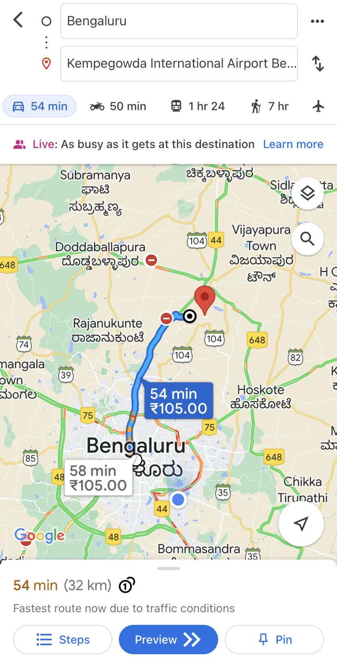

## Public Transport

### A lot of limitations

The distance and location leave the passengers with very few transport options to reach the airport. Normal city buses and metro rail do not service the airport in Bangalore.  
Although there is a newly inaugurated suburban train service connecting the city to a new railway station near the airport, this station is still 4.5 km away from the departure and arrival terminals. Moreover, there are only 6 departures on this train. It seems like the suburban train is more for the employees that work at or near the airport than the passengers.  
*Screen grab of distance between suburban railway station and the airport terminals*  
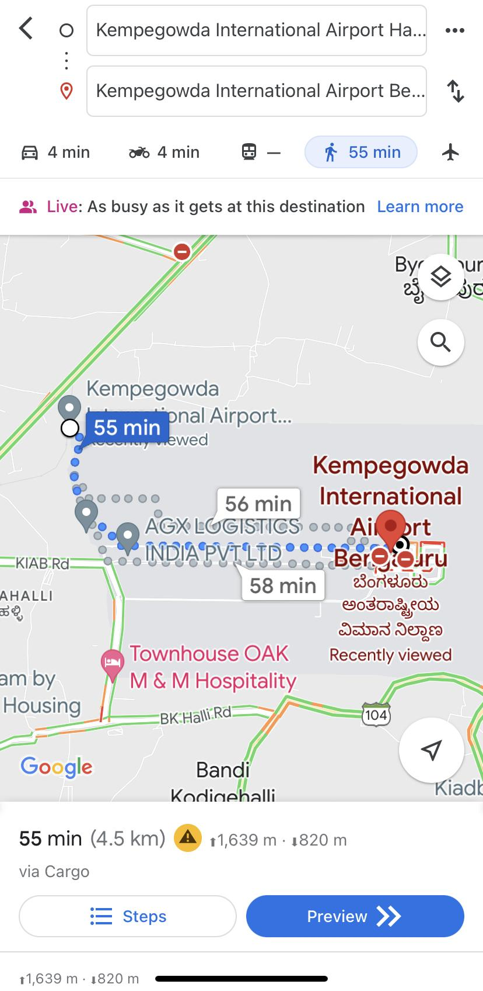

### Only viable option

The only reliable mode of public transport connecting the city and the airport terminals is the Vayu Vajra service, which is an air-conditioned bus service by the city transport department. It connects various parts of the city with the airport. There are challenges associated with the service:

* 1. High-cost: Three people taking the service will spend the same if they took a cab. This makes it cost-effective only for passengers travelling alone and just about worthy for 2 people travelling together.
  2. Low Frequency: There is a bus every 20 minutes during peak hours at most routes. This gap increases to 30-40 minutes during off peak hours.
  3. Limited Last-mile Coverage: The buses cover a large area of the city covering almost the entire city. But, the challenge is the availability of stops near people’s houses. The stops are only at the major arterial roads of the city. Passengers living far from such roads need to take another transport to reach the stop, especially if they have luggage.
  4. Travel time: The bus takes set routes which are usually not the shortest ones. Also, due to the erratic traffic conditions in the city, and heavy traffic at peak times, the bus service takes a longer time to reach the airport as compared to a direct cab service

## Anxiety during travel to the airport

Due to the irregular traffic conditions and the large distance, passengers travelling from the city to the airport face anxiety fearing that the travel time might exceed their estimation.

Another reason for the anxiety is that passengers don’t know the situation at the airport: whether there will be a long queue for luggage drop and security check.

## Private transport

Cabs to the airport are available by a number of operators. Below are a few concerns with these services:

* 1. Availability: The cabs are not always available readily during peak hours or during adverse weather conditions.
  2. Reliability: Cab services, even if booked well in advance, get cancelled or do not show up at the desired time.
  3. Cost: This is a major problem with the cab services to the airport. The costs are exorbitant and go up considerably during peak hours. Also, the fastest route that connects to the airport from the city is a tolled road, further adding to the cost.
  4. Safety: With overworked drivers and poorly maintained vehicles, the incident rate is higher than usual. Especially because of a high-speed highway being part of the route.

*Screengrab of cab prices from a highly populated part of the city. Enquired on a Tuesday evening.*

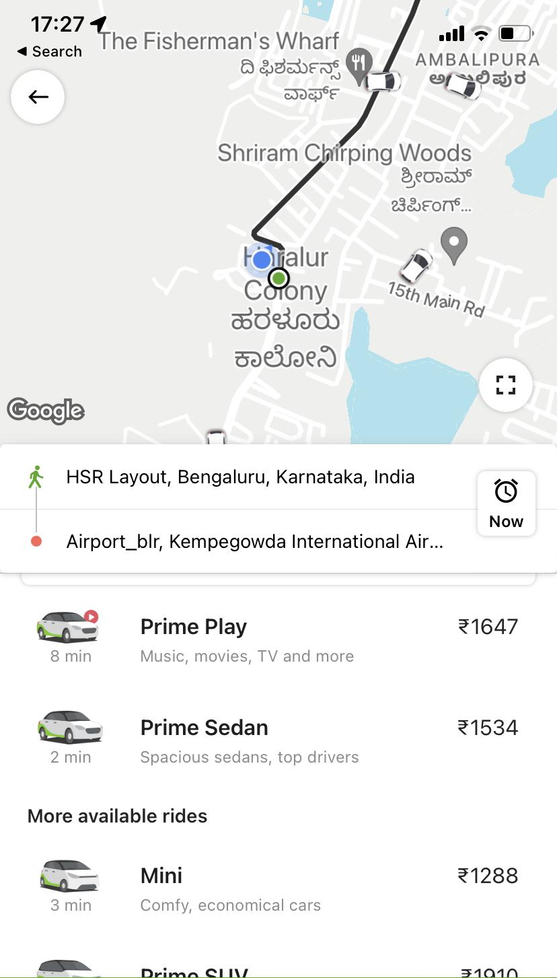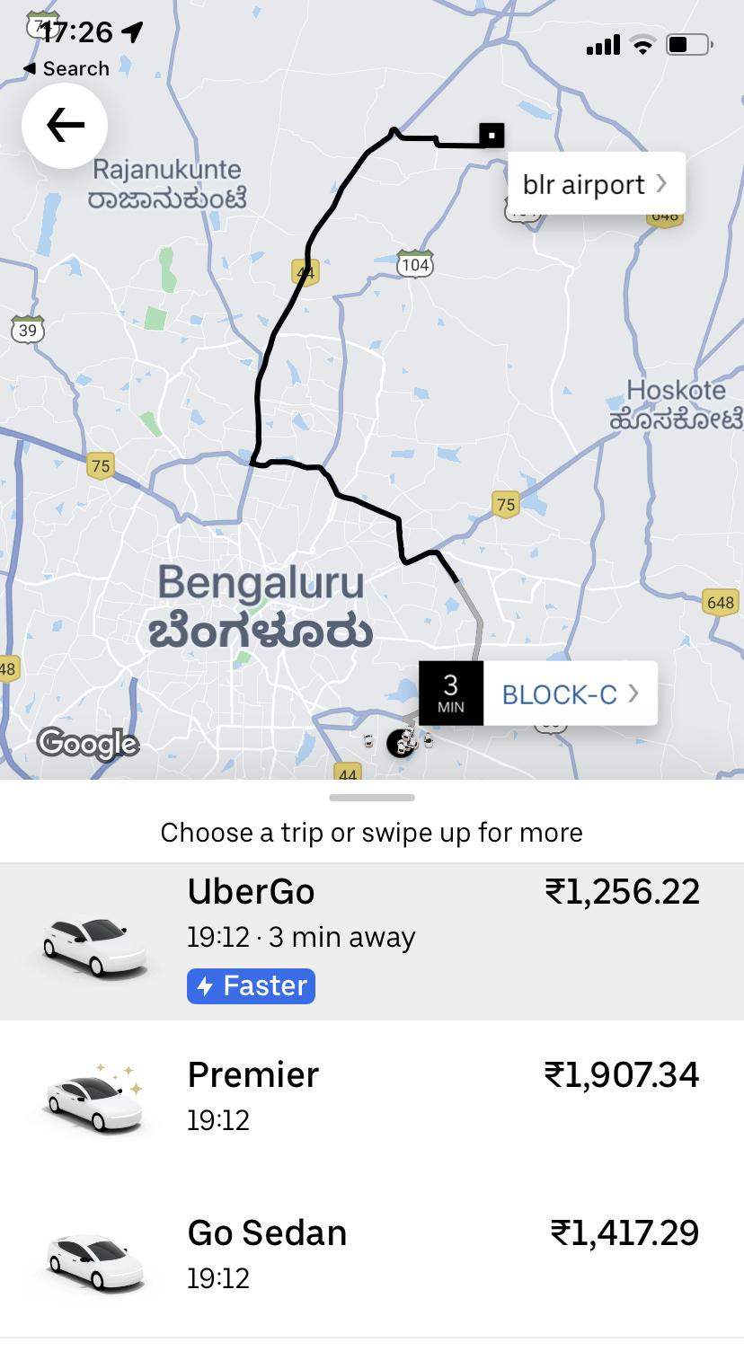

*Screengrab of cab prices from a highly populated part of the city. Enquired on a Monday morning.*

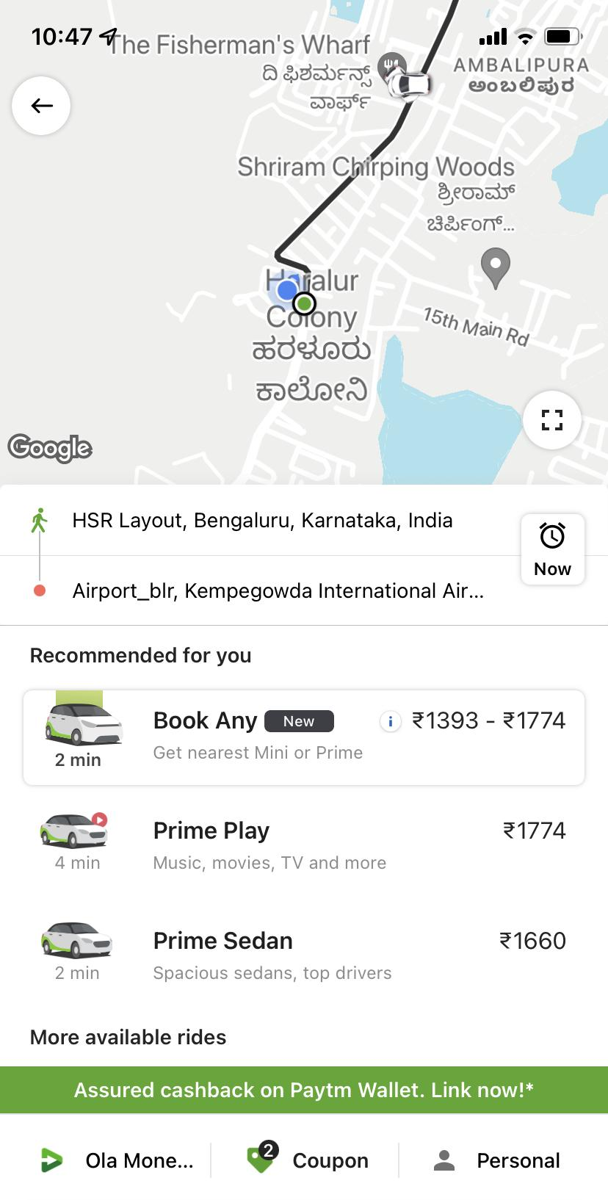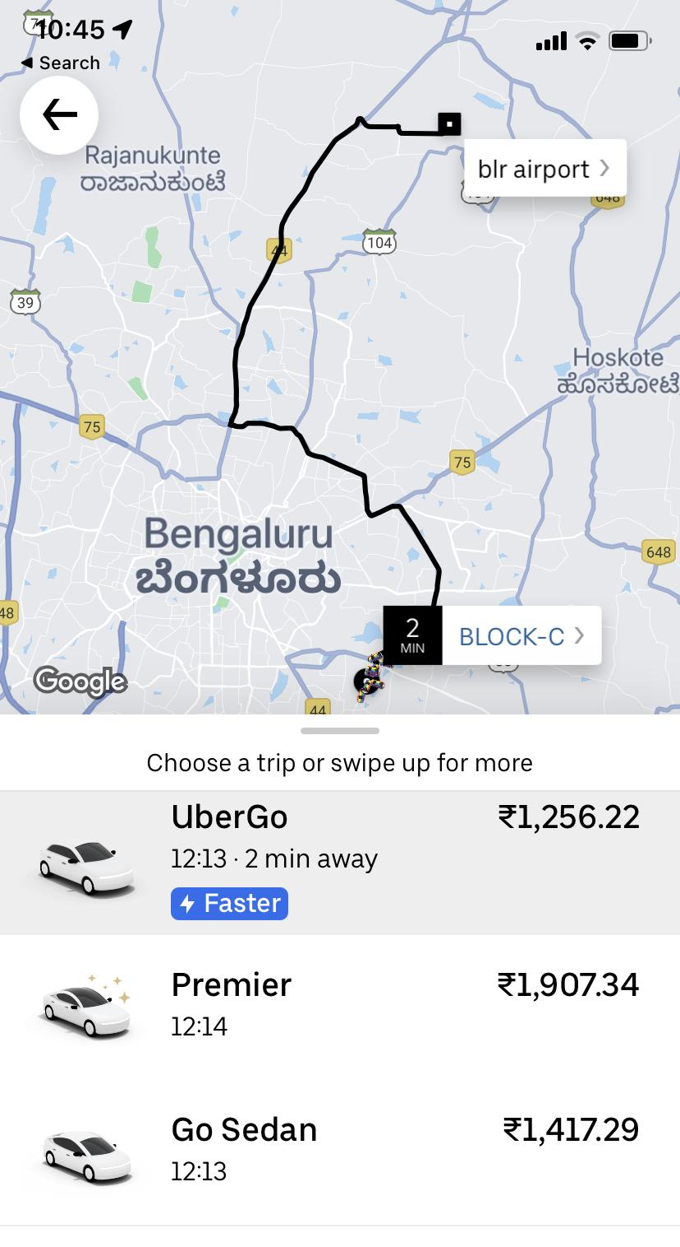

# AirLift Features and Details

AirLift is a bus service from the city to the airport, aimed at solving the problems faced by air travellers in reaching the airport to catch their flight.

Following are the features and details of the proposed AirLift service. These have been conceived keeping in mind Bangalore as a location but can be extended to other locations

## Nudge and Booking process

AirLift being a new service, it is essential that passengers get a nudge while booking their flights using our website or mobile app (or agent partner).

There are 2 ways the users will be made aware of the service and nudged to use it

1. When the users select a flight and if the departing airport has AirLift available, the nudge comes at the step when users are confirming the flight.  
   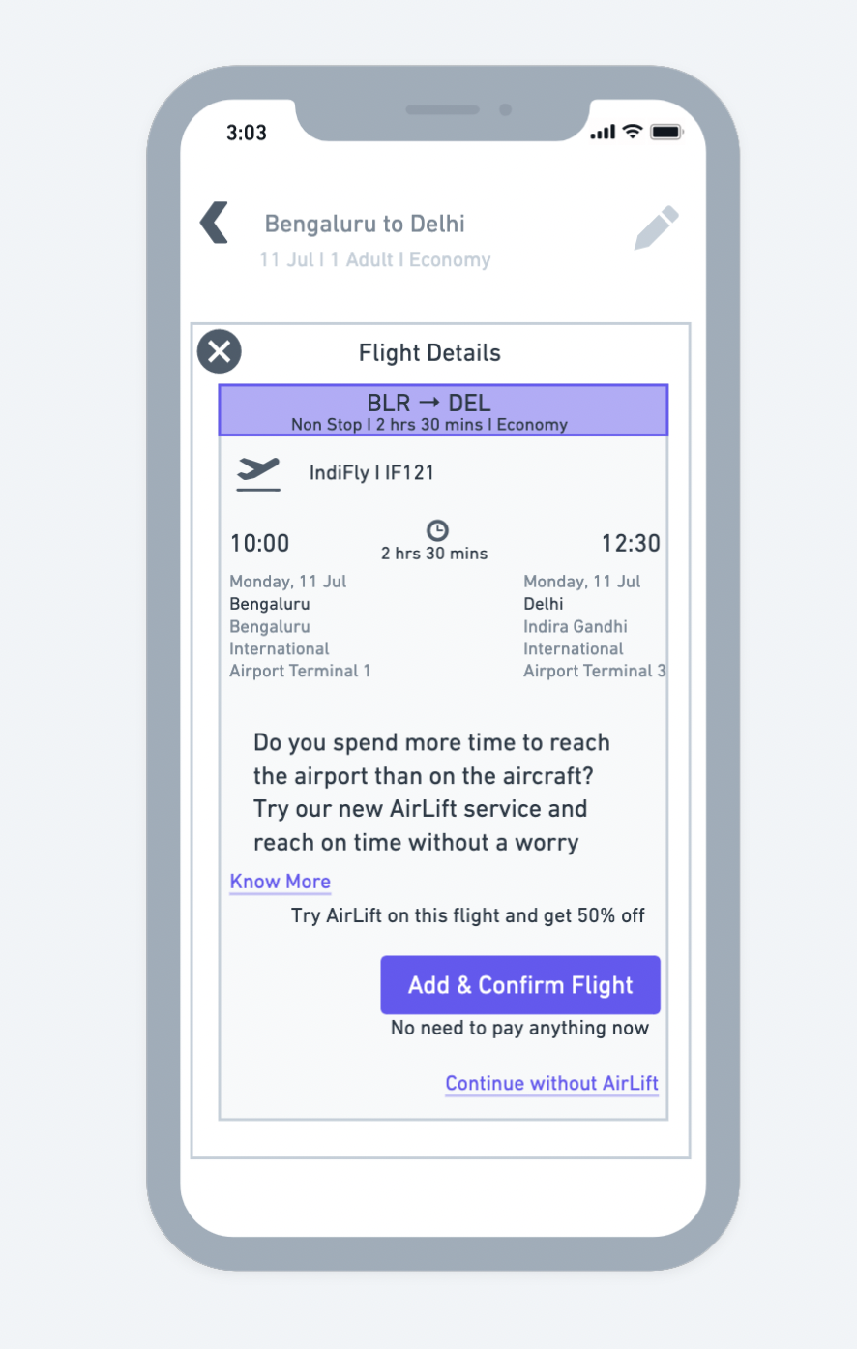
2. Another nudge driving users to book AirLift will be at the flight add-ons page. To push the action to use AirLift, it will be shown as the first tab.   
   The AirLift tab will take the user's location automatically and also give the option to add a different location.  
   If available, the passenger will be shown the charges, which will be determined according to distance from the airport, pick-up spot accessibility and flight timings.  
   If the user agrees they can go ahead and book the service.  
   The flow is as shown below:  
   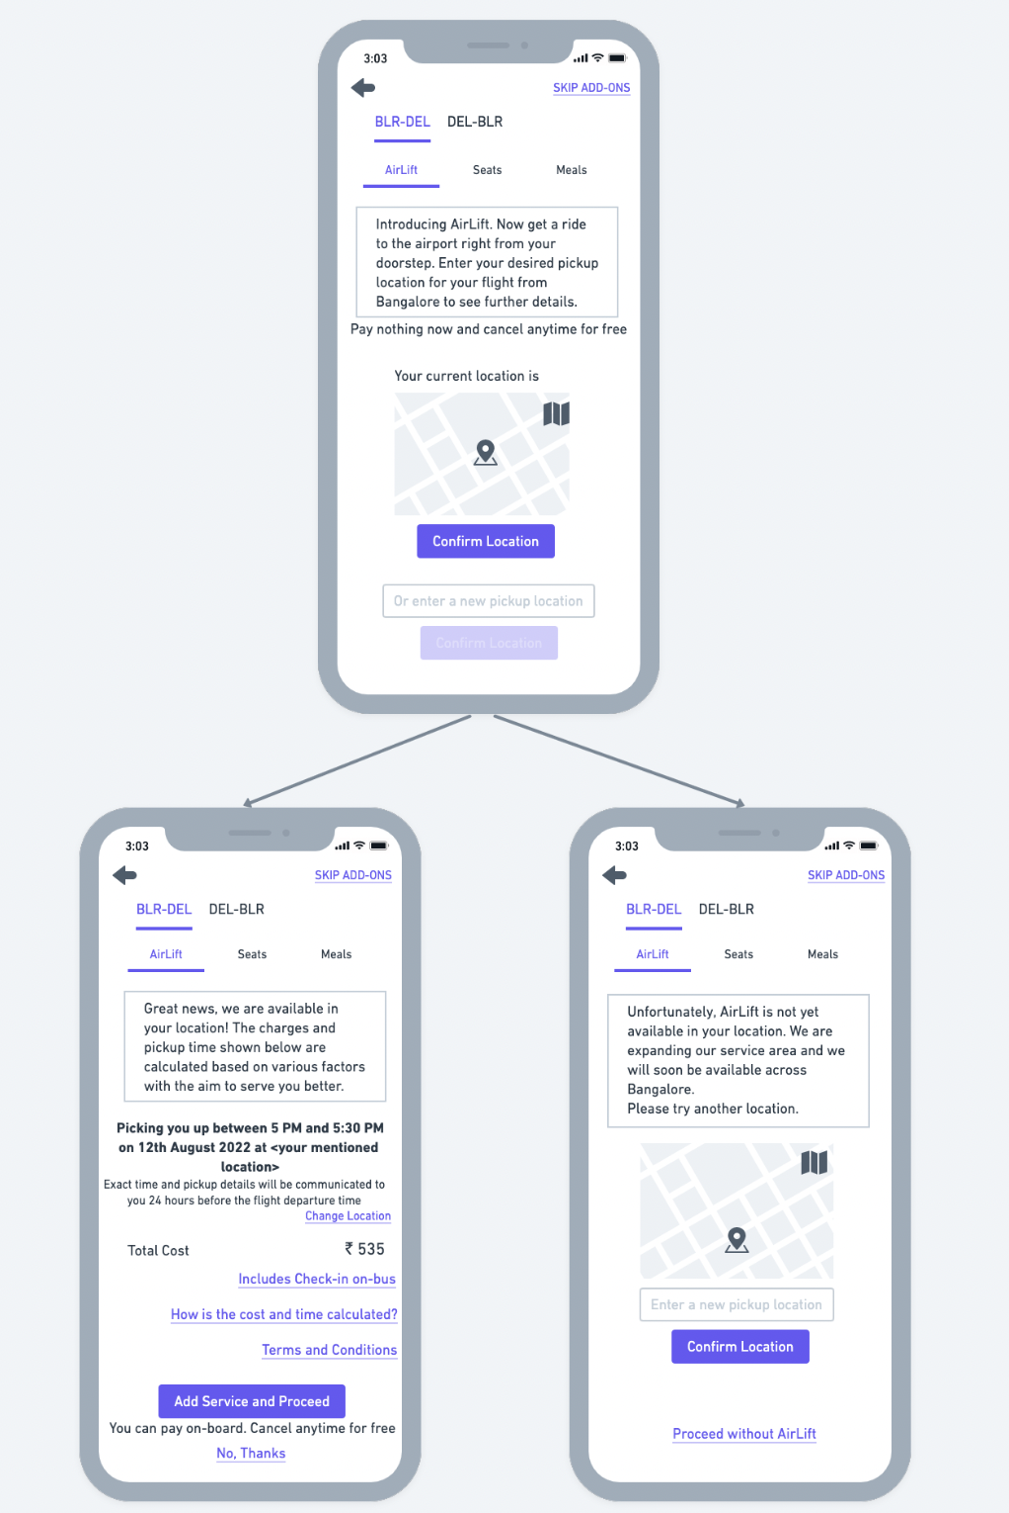
3. Once the user confirms AirLift, it will be added to the cart, but charges won’t be included to give the user an option for booking the service without commitment. A pay-on-board feature will be given. This is to eliminate any risk from the user’s perspective.  
   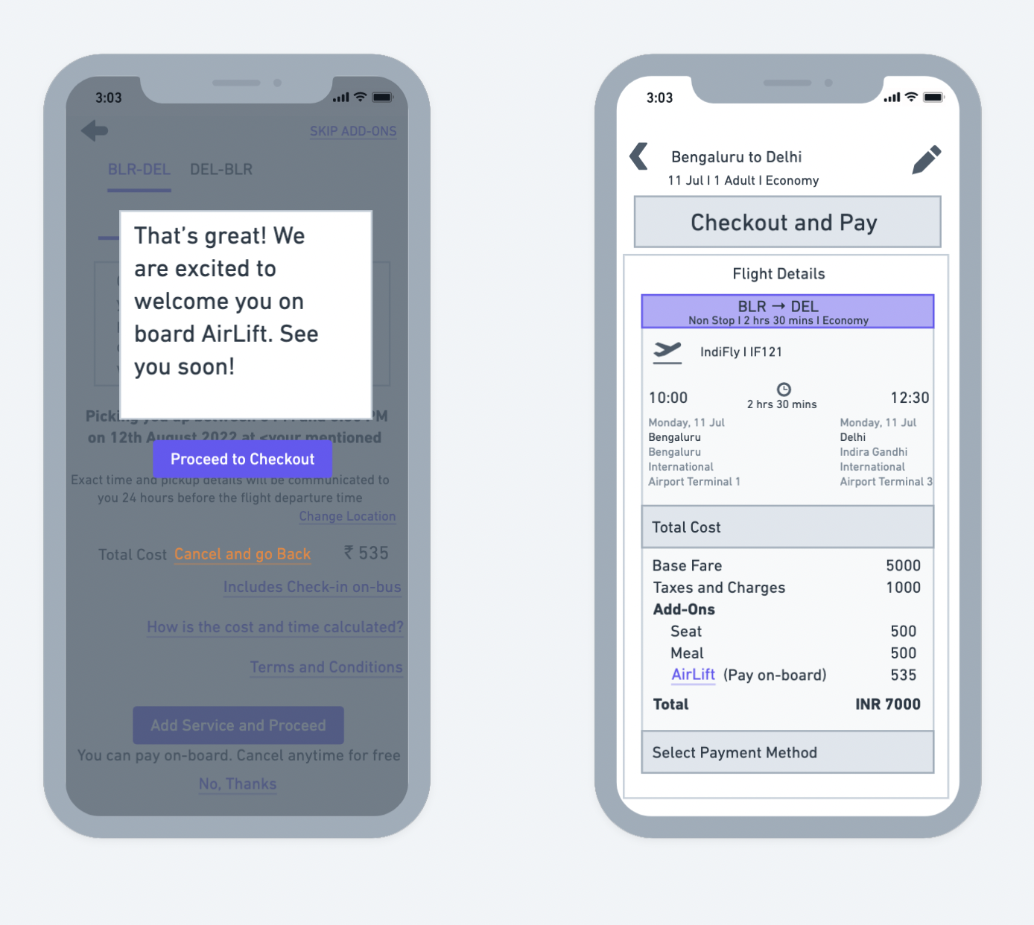

## Other Operational Elements of the service

Since AirLift is essentially a bus service for air passengers, there are a lot of operational aspects to consider. The details for these will be shared in future documentation. Below is a list of those elements:

### The bus

The procurement model, type, size and number to procure.

### Route and pickup

Determining the best route in terms of time taken, coverage, passenger convenience, etc.

### Communication, Tracking and Boarding the bus

How to communicate with the booked passengers to coordinate boarding, schedule changes, verification, etc. Also, a system for passengers to track the bus and be able to board it.

### Services on board the bus

Is it possible to add a check-in facility in the bus itself? What are the services that can be offered on board the bus?

## Price Estimate

* A dynamic price determination logic will be used to show service prices to the passenger while booking the flight ticket.
* A/B tests to determine price sensitivity for passengers booking the service.

# Risks

Below are a few risks associated with the AirLift service and the plans to monitor/ mitigate the risk:

1. Low occupancy  
   There is a risk that passengers do not find the service useful or too time-consuming compared to cabs.   
   In case we see this happening we could try switching to smaller buses with fewer passengers. This will limit pickups and reduce travel time.
2. Improved metro connectivity  
   If the metro connectivity improves in a few years passengers could move on from AirLift to the metro as it will provide faster transit times and cheaper fares.  
   In such a case, there will be enough time to respond, and AirLift will have to be enhanced to further improve the value proposition and target it more towards specific types of passengers.

# Metrics to consider

The future roadmap of AirLift depends on the response received during the initial phase.

The following metrics would be in-focus to gauge the response of the service:

1. Percentage of bookings with AirLift  
   The percentage of eligible users opting to use the service. This will give us an idea of the acceptance of the service and the need to increase awareness.
2. Occupancy Rate  
   The percentage occupancy for the buses. A distribution of occupancy according to different parameters such as time of day, route, time of year etc. will give an idea about the service's popularity and response from the passengers.
3. Denied requests  
   This metric will help us understand how many passengers are willing to book the service but are unable to because of unavailability. It will give us details on new locations to focus on and areas where demand is more than supply
4. Point of skipping service  
   This metric gives us details on where the user decides to not use AirLift. For eg: if more users drop off at the pricing page, it indicates that price is the deciding factor for users to drop off.

# Future Roadmap

Provided we see favourable metrics and the service shows growth potential, the following could be part of the roadmap in the future:

1. Investment in assets
2. Multiple service classes
3. Dynamic pricing